**VISITOR ATTENDANCE SYSTEM ARCHITECTURE.**

**Sequence diagram.**

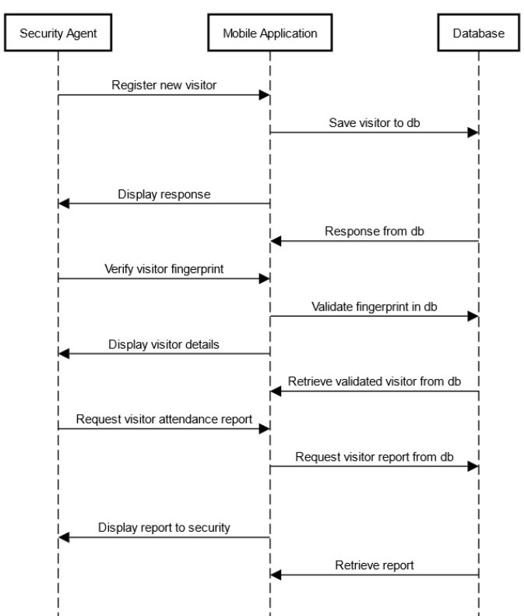

**Component Diagram.**

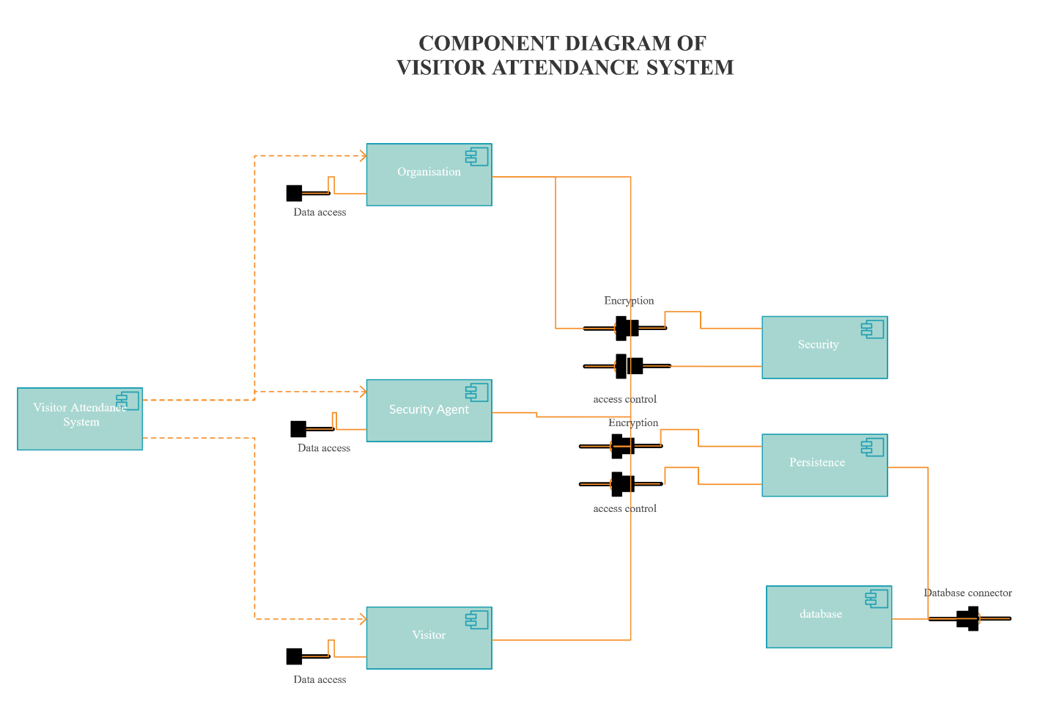

**Use cases.**

The Visitor Attendance Application is used by an organization to check in and out visitors.

The following are the use cases.

**Manage Visitors:** New visitors are added to the system together with various information e.g. personal information, family information, payroll information and fingerprint. The data is store both locally and online. This helps in situation where internet is not available. When the device gets connected to the internet, all the data is synchronized to online database.

**Verify Visitors:** After visitor registration, he/she is ready to verify fingerprint at any time while checking in or out. Verification involves fingerprint recognition after which all the useful data of the visitor including image is displayed. The visitor is then allowed to visit the organization. Failure to verify results to the employee being barricaded from the organization.

**Manage Attendance:** All attendance records are stored both locally and online. Incase report is needed, the dates are selected then report can be generated. This information helps company to track all visitor attendance.